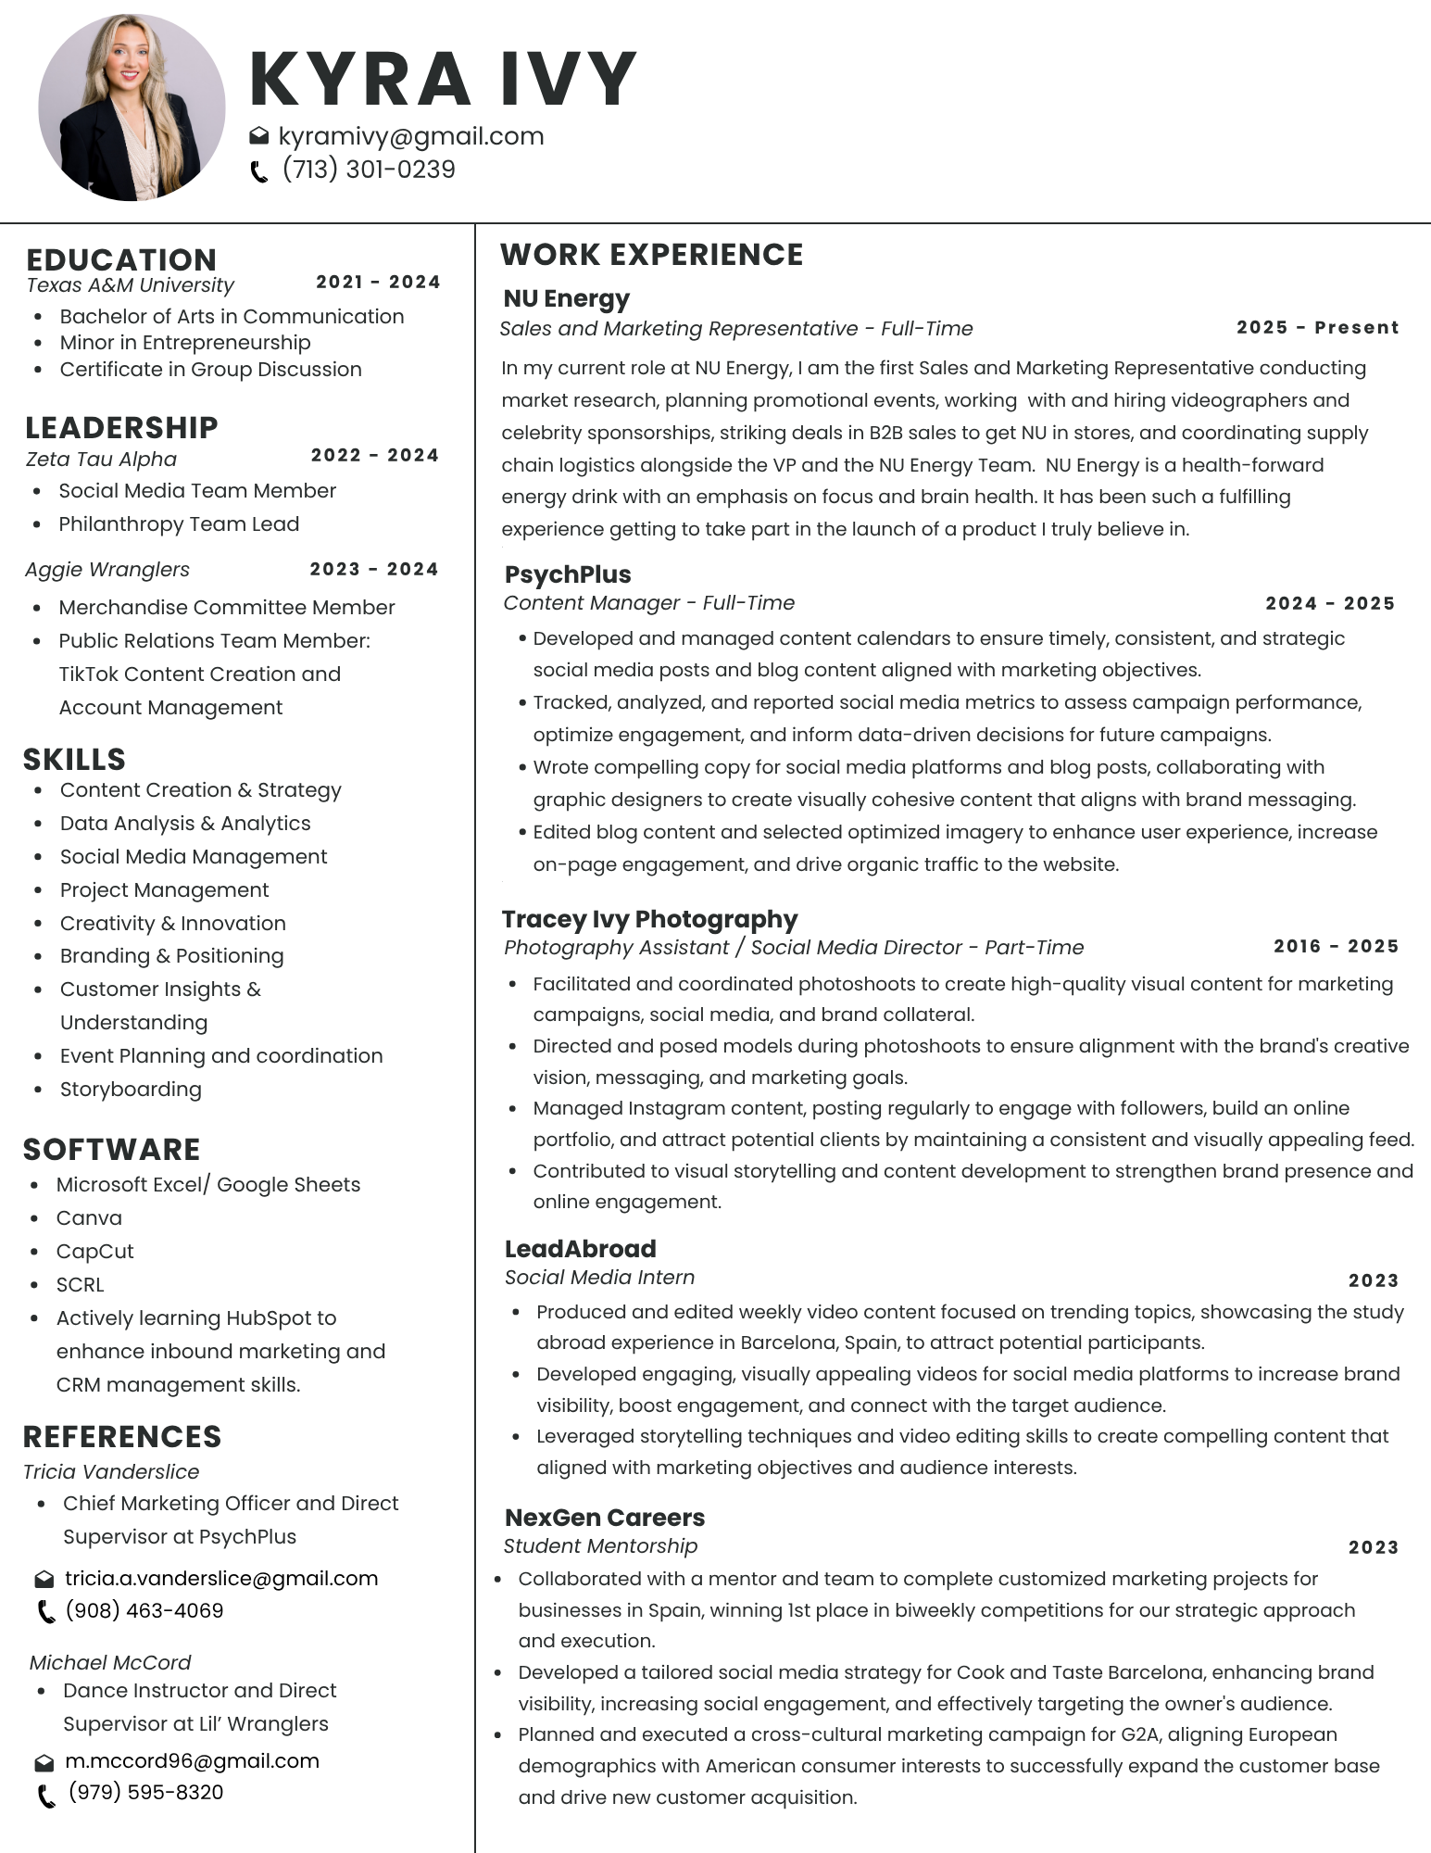

Further Description for my current role at NÜ Energy

Developed and implemented the company’s first marketing and sales operating procedures, including vendor documentation, client visit forms, and SOPs for inventory, shipping, and fulfillment.
Secured new wholesale partnerships with local gyms, wellness studios, and hospitality groups, including HOTWORX and DUO Houston, expanding retail visibility.
Led brand activations and pop-up events, including planning, staffing, creative direction, and post-event reporting for collaborations such as BLVD x NÜ Energy, White Linen Night, and Lifetime Fitness.
Managed social media marketing and content production — developed post schedules, captions, influencer collaborations, and lifestyle campaign concepts to align with quarterly KPIs.
Recruited, contracted, and managed brand ambassadors and influencers, coordinating deliverables, payments, and UGC content for cross-platform promotion.
Collaborated with leadership on key brand materials including sales decks, client proposals, and KPI presentations used for internal and investor reporting.
Supported Amazon and Shopify e-commerce setup, product listings, customer communications, and promotional campaigns to drive online sales.
Analyzed competitor strategies and customer insights to shape messaging, improve social engagement, and inform pricing and product positioning.
Created documentation systems to streamline workflows and support ongoing marketing automation and client communication.
Partnered with creative and operations teams to ensure inventory accuracy, fulfillment efficiency, and brand consistency across digital and physical touchpoints.

